Geometry: Unit 10, Lesson 6
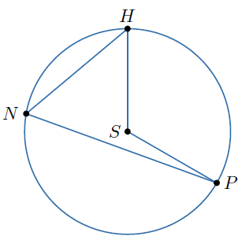
- Circle $S$ is shown, where points $H$, $P$, and $N$ lie on the circle.$∠HNP$ is an inscribed angle of circle $S$ and $m∠HSP=120°$. What is the measure of $\hat{HP}$?

$$120°$$

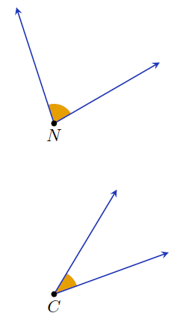

- Angles $N$ and $C$ are shown, where $m∠C=\left(4x+3\right)°$, $m∠N=\left(9x-3\right)°$, and $m∠C=\frac{1}{2}\left(m∠N\right)°$. What is the value of $x$?

$$x=9$$
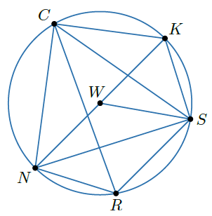
- Circle $W$ is shown with points $C$, $N$, $R$, $S$, and $K$ on the circle. What are the central angles?

$∠NWK$, $∠KWS$, $∠NWS$

